8th Annual Jefferson Health Lung Cancer Screening Summit



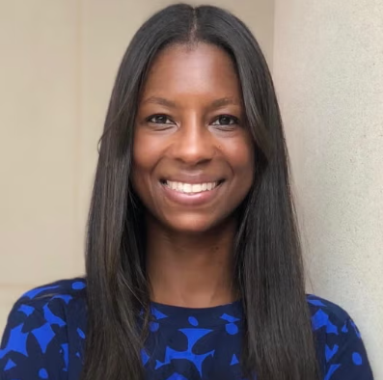

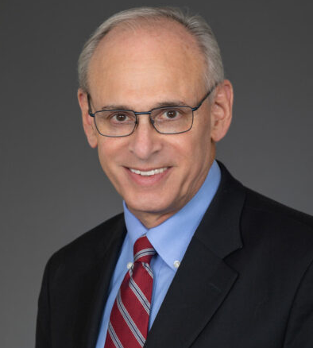

The 8th Annual Jefferson Health Lung Cancer Screening Summit aims to review the latest knowledge and research advances in the fi eld by bringing together a multi-disciplinary group of physicians, nurses, program coordinators, researchers, and other experts.
The vision for the Jefferson Health Annual Lung Cancer Screening Summit is to develop a nationally recognized educational program that brings together clinicians and researchers focused on early detection of lung cancer.

Keynote: Randi M. Williams, PhD, MPH
Randi M. Williams, PhD, MPH is an Assistant Professor of Oncology at Georgetown University and a member of the Lombardi Comprehensive Cancer Center’s Cancer Prevention and Control Program.
She co-leads the Lung Screening, Tobacco, and Health Lab, focusing on increasing the adoption of evidence-based lung cancer prevention and screening practices. Her work centers on reducing disparities in underserved populations through multilevel interventions that improve patient–provider communication and screening uptake.
Dr. Williams leads several federally funded projects, including efforts to enhance lung cancer risk prediction for people with HIV and to evaluate cessation treatments within lung screening programs. At Georgetown, she also helps guide dissemination and implementation initiatives, mentors postdoctoral fellows, and contributes to curriculum reform aimed at advancing racial justice.
Keynote: Richard Wender, MD
Richard Wender, MD is Chair of the Department of Family Medicine and Community Health at the University of Pennsylvania’s Perelman School of Medicine, where he leads efforts to strengthen primary care, advance population health, and confront social determinants of health to promote equity.
Over more than three decades at Thomas Jefferson University, he helped build pioneering programs in geriatric and palliative care, refugee health, community partnerships, and value-based primary care. As the first Chief Cancer Control Officer of the American Cancer Society, Dr. Wender guided major national initiatives to expand colorectal cancer screening and HPV vaccination, and he played a key role in ensuring safe access to cancer screening during the COVID-19 pandemic.

Successful Completion
To successfully complete this activity, the required evaluation must be completed no later than Wednesday, October 21, 2026. Thereafter, the evaluation will no longer be available and credits will not be issued. No refunds will be offered for failure to complete the required evaluation by the stated deadline.

Objectives
1 Explain state of the art of lung cancer prevention, diagnosis, and management.
2 Examine the utilization of a multidisciplinary team in the deployment of lung cancer screening.
3 Employ the latest community outreach strategies to reduce lung cancer disparities around the region.
4 Identify patients that are ideal candidates for lung cancer screening.
5 Compare their individual and/or team practices to the information and discussions during the course.
6 Identify specific strategies to implement as part of a continuing improvement process for their practices.
7 Employ best practices shared during the conference in interactions with multi- disciplinary teams to improve patient care.
8 Practice collaboration with MA, CRNP, and physicians around lung cancer screening best practices.
9 Employ the latest community outreach strategies to reduce disparities around the region.
10 Practice mutual respect, trust, integrity, high standards of ethics while valuing differences when working with members of other health professions in the common goal of providing high quality, patient-centered health care.
11 Recognize individual roles and the roles of others in the healthcare team to interact as a dynamic collective unit in the delivering of health services to patients.
12 Employ a communication strategy that merges observations, expertise, and decision-making of the healthcare team to optimize patients’ care.
13 Apply relationship-building values and the principles of collaboration in caring for lung cancer patients.


In support of improving patient care, Thomas Jefferson University is jointly accredited by the Accreditation Council for Continuing Medical Education (ACCME), the Accreditation Council for Pharmacy Education (ACPE), and the American Nurses Credentialing Center (ANCC), to provide continuing education for the healthcare team.

Physicians: This educational activity is designated for a maximum of 7.00 AMA PRA Category 1 Credit(s)™. Physicians should claim only the credit commensurate with the extent of their participation in the activity.

Nurses: This activity awards 7.00 nursing contact hour(s).

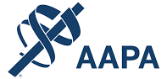

Physician Assistants: Thomas Jefferson University has been authorized by the American Academy of PAs (AAPA) to award AAPA Category 1 CME credit for activities planned in accordance with AAPA CME Criteria. This activity is designated for 7.00 AAPA Category 1 CME credit(s). PAs should only claim credit commensurate with the extent of their participation.

October 1, 2026 at 7:00 AM

Dorrance H. Hamilton Building

For more information,
call (215) 955-6992 or toll free at 1-877-JEFF-CPD

